MECH 420 – Lab Report 6

Kyle Ah Von #57862609

## Part A

1. Find the actuator position (equilibrium) as a function of coil current X(𝐼𝑐𝑜𝑖𝑙) and provide a graph for each spring including the predicted behaviour. Point out the stable operating range for each spring.

The theoretical relationship between actuator position and coil current is as shown above. We can then plot the measured data for each spring alongside their theoretical data.

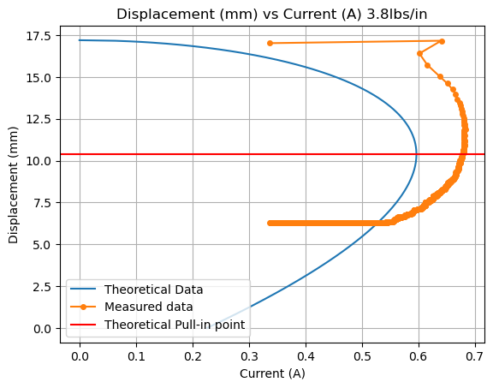

Figure 1: Displacement vs Current 3.8 lbs/in

Figure 2: Displacement vs Current 8.4 lbs/in

The stable operation range is where the slope of the response is positive before the pull-in point is reached. The range of displacement varies with different spring constants.

Figure 3: Displacement Ranges for each spring

With the 3.8 lbs/in spring, the stable operating range is between 0.55 A to 0.68A. Whereas for the 8.4 lbs/in spring, the operating range is between 0.45 A to 0.78A.

## Part B

1. Find and plot the magnitude of the velocity per current 𝑖 as a function of frequency, the transfer function of the system for either bias current (current offsets 100 mA and 250 mA) and compare the transfer function magnitude as a function of frequency with the model prediction (derived as part of the pre-lab).

Figure 4: Fitted Curve with Prediction Model

The measured transfer function of |G(ω)| is obtained by calculating the velocity using the sampling rate and taking a ratio with the small current variation. The resulting transfer function is shown in figure 4.

The predicted model is in dark orange. The magnitude values do not match up to the measured values however, the resonant frequency of the predicted model and the measured data matches up very closely at around 12.75 Hz.

Figure 5: 250 mA Magnitudes

The measured transfer function of |G(ω)| is obtained by calculating the velocity using the sampling rate and taking a ratio with the small current variation. The resulting transfer function is shown in figure 4.

The predicted model is in dark orange. The magnitude values do not match up to the measured values (The theoretical signal was scaled up to attempt to match the two graphs visually) however, the resonant frequency of the predicted model and the measured data matches up very closely at around 14.0 Hz.

1. Identify the resonant frequency for both bias currents in the experiments and compare these frequencies with the model prediction.

The Theoretical Resonant Frequency using 100mA can be calculated using this expression:

The measured resonant frequency is about 12.75 Hz which is within what is experimentally acceptable.

The theoretical Resonant Frequency using 250 mA can be calculated using this expression:

The measured Resonant Frequency is found to be 14.31 Hz, which is also within what is experimentally acceptable.

1. For the sinusoidal excitation at zero bias, plot the current and the position as a function of time. Comment on your observations.

Figure 6: Current vs Time

At zero bias, the current signal peak at about 0.5 A, while the through goes slightly below zero, indicating an alternating behavior. The measured sine signal is however not center around 0 A as expected from the zero-bias current. There seems to be an inherent offset of about 0.2A.

While the setting of the function generator is set to 600 mV peak to peak, the peak-to-peak current signal is slightly more than 600 mV.

Figure 7: Displacement vs Time

The graph displays the displacement (in mm) as a function of time (in seconds) for the first 200 data points. We can draw multiple conclusions:

1. **Non-Sinusoidal Oscillations**: Unlike a smooth sine wave, the displacement exhibits irregular oscillations with varying amplitudes and periods, indicating complex dynamics in the system.
2. **Peak and Trough Variations**:
   * The maximum displacement fluctuates, suggesting instability or external interference in the system.
   * The minimum displacement also varies, with sharp dips in certain regions, likely due to sudden changes in force or external inputs.

**Possible Explanations:**

* The irregular behavior could result from:
  + External disturbances acting on the system.
  + Nonlinear dynamics or chaotic behavior.
  + Measurement artifacts in the displacement sensor.